DS-A5 | Time-Series Rolling Evaluation Lab
Purpose: This guide demonstrates temporal evaluation mechanics on a separate synthetic daily-demand task. The assessment itself requires the student to choose a real dataset and justify its temporal boundaries, critical period, and operational policy.
Origin data website: https://archive.ics.uci.edu/dataset/321/electricityloaddiagrams20112014 and https://forecastingdata.org/
Data provenance: 720 synthetic daily rows, generated using seed 2026. Local CSV SHA-256: dcfbc7cc577864da600cecd328795a1291d95fdf541c657ec2efcbfcb92e8250. A level shift and increased noise are deliberately injected at index 480;

Frozen demonstration protocol
Six expanding rolling origins (indices 360, 420, 480, 540, 600, 660), each with a 30-day horizon. Candidates: persistence, 7-day seasonal naive, and a Ridge lag model. Each fold fits imputation and scaling only on that fold's training window. Features use lags and rolling statistics ending at t‒1.
What is not decided here: here is your assessed dataset, feature/label reporting delays, target and horizon, real rolling origins, critical-period rule, primary metric, drift trigger, retraining condition, fallback, and final claim boundary.
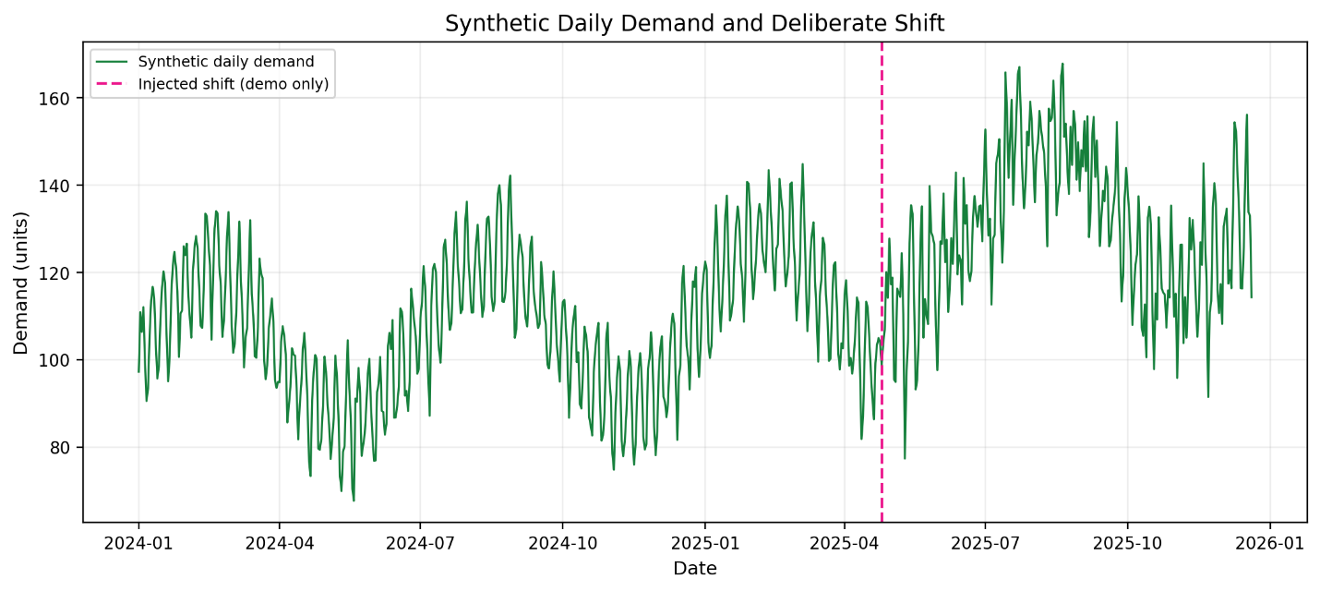
Figure 1. Synthetic series with deliberately injected shift; used only to illustrate the evaluation design.

Rolling-origin performance
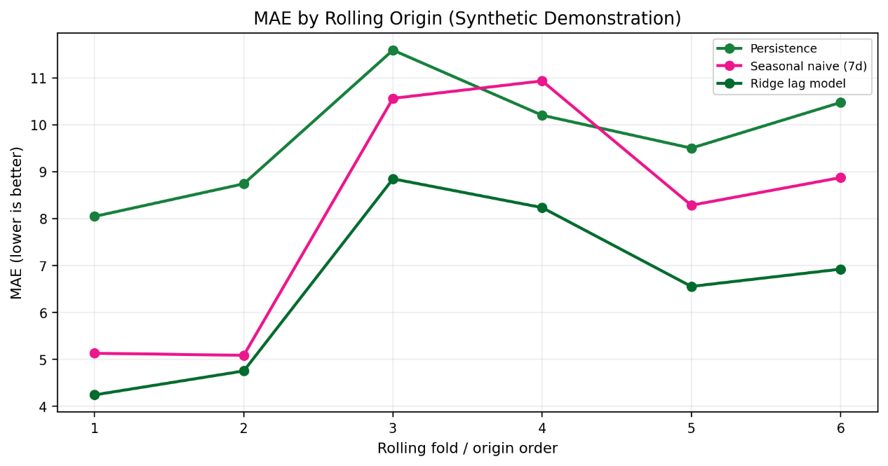
Figure 2. Mean absolute error by origin. A single overall mean can hide time-local degradation, so inspect fold-level metrics and raw predictions.

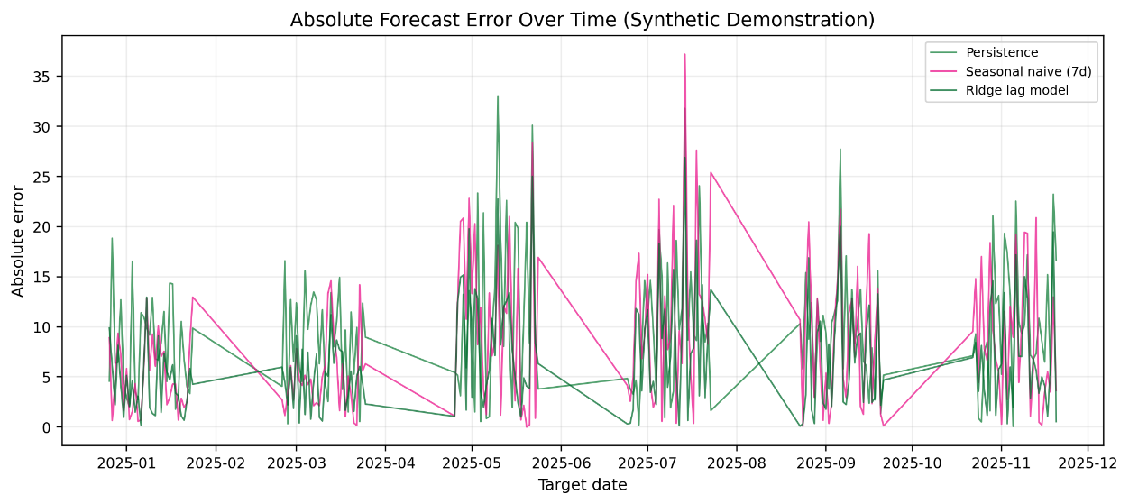
Figure 3. Absolute errors over time. For a real assignment, identify the critical period using a predeclared rule and connect it to observable evidence rather than selecting it only because errors look dramatic.

Demonstration mean metrics
These metrics only describe this generated toy series. They must not be presented as findings about the student's real dataset.
Model | Mean MAE | Mean RMSE
Persistence | 9.76 | 11.55
Ridge lag model | 6.59 | 8.17
Seasonal naive (7d) | 8.15 | 10.19

What the shift does to forecasts
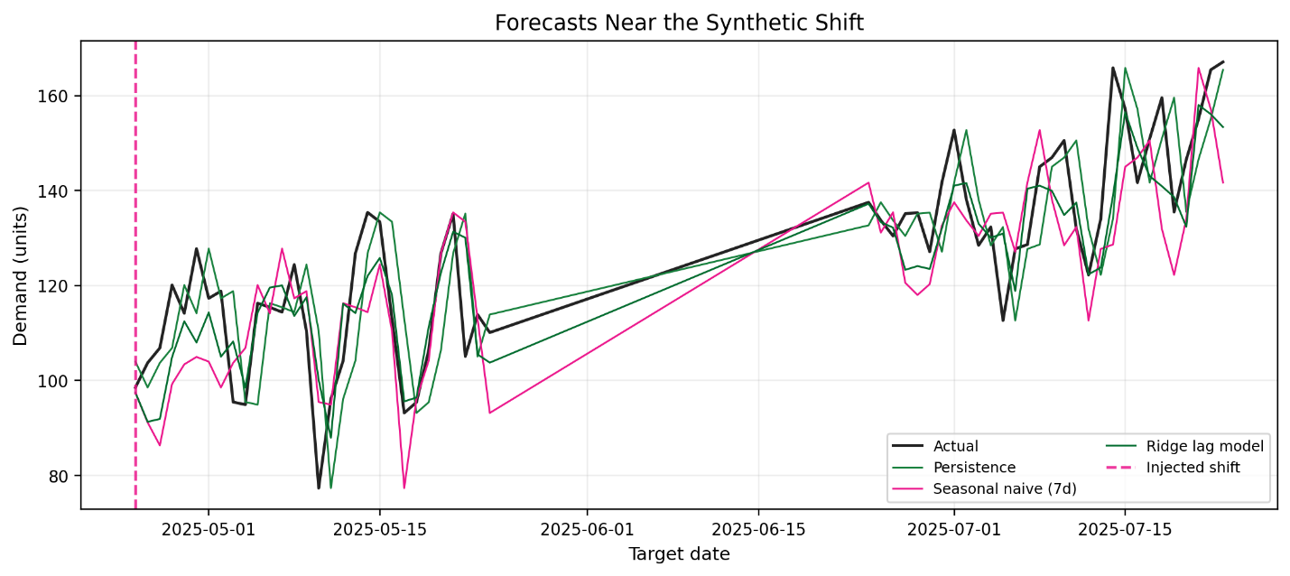
Figure 4. Forecasts around the deliberately injected level/noise shift. A lag model cannot know about an unannounced future level change unless the change is represented in information available at forecast time.

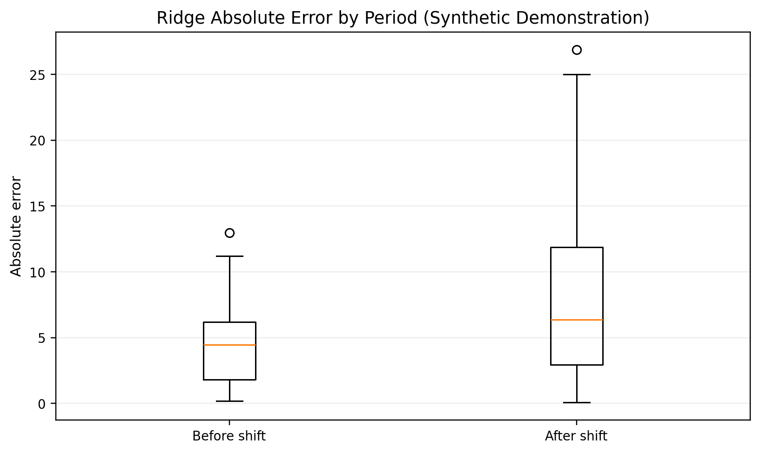
Figure 5. Ridge absolute error before and after the injected shift. Treat period comparisons cautiously: folds, sample counts, seasonal composition, and overlapping forecast windows can affect interpretation.

Temporal leakage checks to adapt
For each origin, verify that all training labels were actually available by that origin—not merely that their event timestamps are earlier. Feature values must also have been published/received by the origin. Rolling statistics must exclude the target timestamp.

